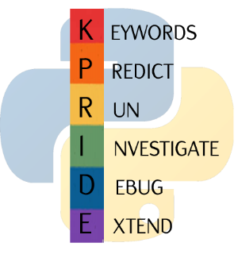

Python for GCSE

Getting Started

1:

**1.1:**

**understand the basic concept of the python**

**programming language.**



**Keyword**

**Definition**

example of a high level programming language

type of programming language which is hard for humans to read but

which gives you complete control over each aspect of how the

processor actually operates.

a way of describing algorithms using code that can be run on a

computer

running lines of code in a specific order

type of programming language which is easy for humans to read but

which hides some of the detail of how the processor actually

operates to simplify writing programs

1

**high level**

2

**low level**

3

**programming language**

4

**python**

5

**sequence**

**be able to assign and use variables**

**1.2:**



**Keyword**

**Definition**

named memory location used to store a data value which is set once

then never changes

named memory location used to store a data value which can

change while a program runs

setting the value of a variable

the name of a variable or constant

set of rules to follow when choosing names for variables or

constants

the data stored inside a variable

1

**assignment**

2

**constant**

3

**identifier**

4

**naming convention**

5

**value**

6

**variable**

**Input and output to the python console**

**1.3:**



**Keyword**

**Definition**

using data to make calculations

reading data from the user into a program

part of the screen which allows the user to edit python code

part of the screen which allows the user to interact with text based

python programs

sending data out from a program to a user

read evaluate print loop which allows you to run one line of code at a

time

using different colours to help programmers understand code and

spot errors

1

**console**

2

**editor**

3

**input**

4

**output**

5

**process**

6

**REPL**

7

**syntax highlighting**

**be able to understand and use arithmetic**

**1.4:**

**operators**



**Keyword**

**Definition**

mod

add together

symbol which tells python to perform a maths calculation with two

values

increase by

exponent (raise to the power)

decrease by

subtract

divide

1

**\*\***

2

**-**

3

**-=**

4

**/**

5

**%**

6

**+**

7

**+=**

8

**arithmetic operator**

# Predict and Run:

|  |  |  |
| --- | --- | --- |
| **Code** | **Prediction:** | **Actual result:** |
| <https://create.withcode.uk/python/8Sg> |  |  |
| <https://create.withcode.uk/python/8Sh> |  |  |
| <https://create.withcode.uk/python/8Uu> |  |  |

# Investigate:

|  |  |
| --- | --- |
| **Template** | **Investigation** |
| <https://create.withcode.uk/python/8Si>    Change one of the numbers on each line to make  the output 100 |  |

# Debug:

|  |  |  |
| --- | --- | --- |
| **Code** | **Line** | **Problem** |
| <https://create.withcode.uk/python/8Sk> |  |  |

# Extend:

|  |  |
| --- | --- |
| **Create a program that…** | **Link** |
| 1) …asks five questions about a sport of your choice |  |
| 2) …displays each line of a nursery rhyme |  |
| 3) Find all the operators in <https://create.withcode.uk/python/8K2> and try  replacing them with a different operator |  |